**Database System & Web Lab (15B17CI372)**

**Lab 3&4**

**(Week-17th Aug- 27th Aug 2022)**

**NOTICE:**

Lab Evaluation is scheduled in **Week 5: 29th Aug 2022 to 3rd Sept 2022** in your respective labs.

Syllabus: HTML, CSS, JavaScript



Note: It is mandatory to run the SQL commands on MYSQL - Windows Command Prompt.

1. **CREATE DATABASE**

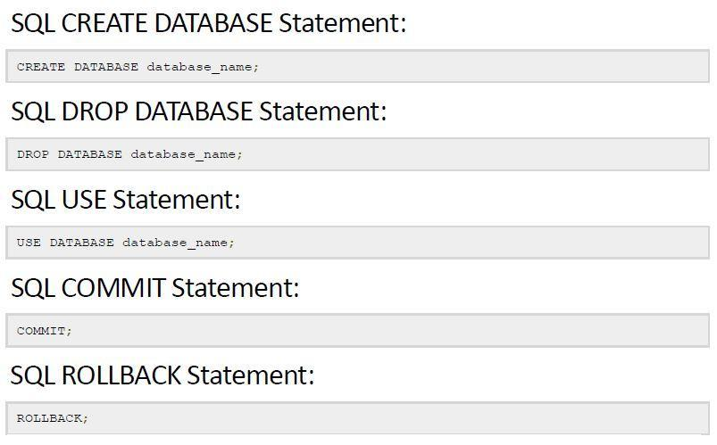

## 1.1. Example

CREATE DATABASE <ROLL_NO>;

USE <ROLL_NO>;

DROP DATABASE <ROLL_NO>;

1. **DATA TYPES IN SQL**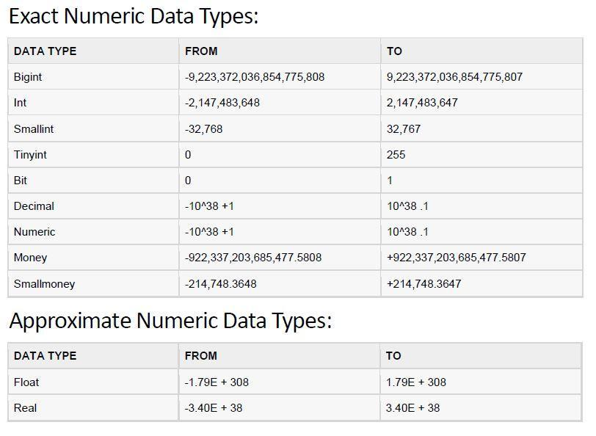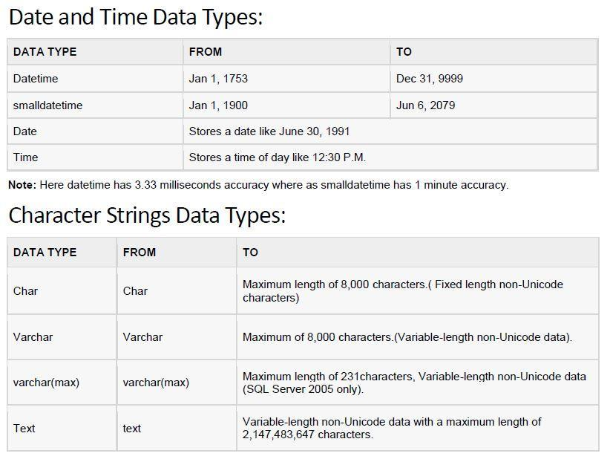

1. **CREATE TABLES (COMPANY DATABASE FROM NAVATHE BOOK)**

Consider the following Entity Relationship (ER) Diagram.

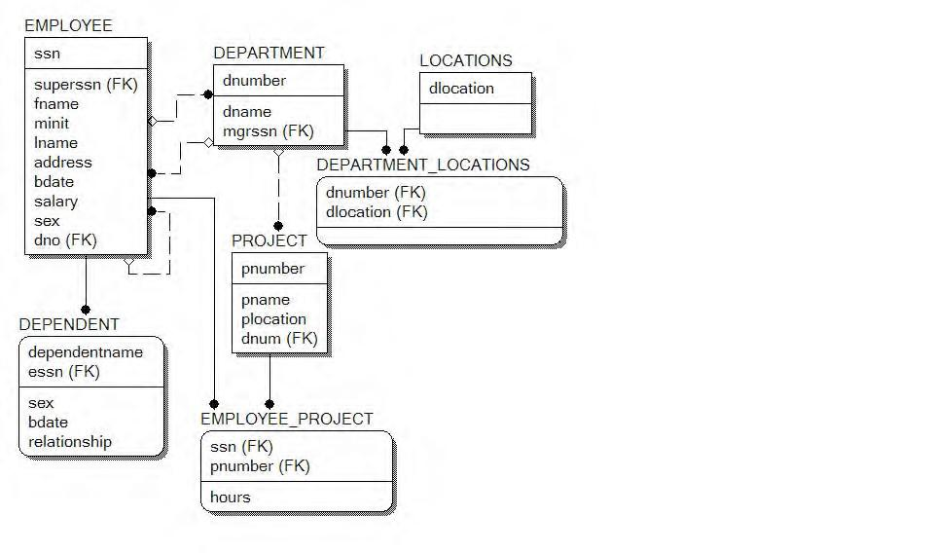

Write SQL command to create following tables: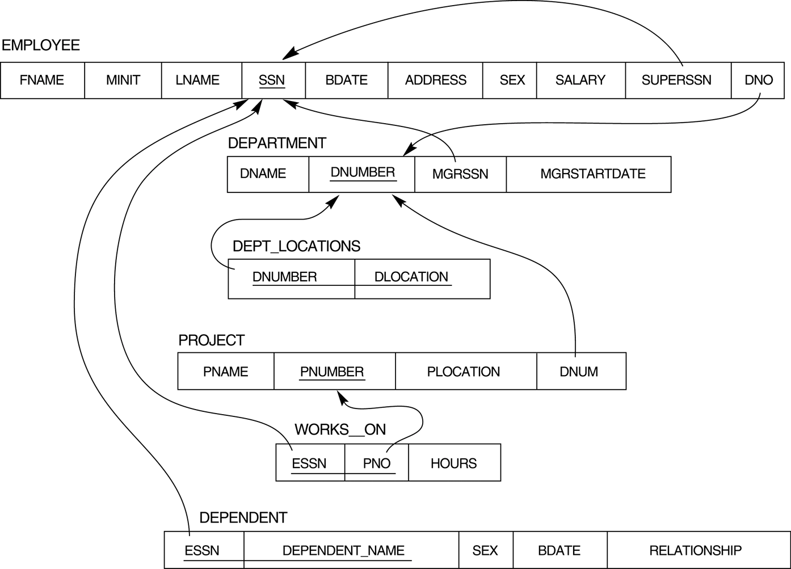

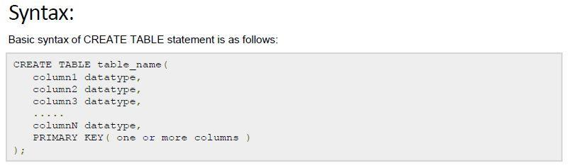

## 3.1. Example:

SHOW TABLES;

CREATE TABLE DEPARTMENT(

dname VARCHAR2(20) NOT NULL ,

dnumber INTEGER NOT NULL ,

mgrssn NUMBER(9) NULL);

CREATE TABLE DEPARTMENT_LOCATIONS(

dnumber INTEGER NOT NULL ,

dlocation VARCHAR2(20) NOT NULL );

CREATE TABLE DEPENDENT(

dependentname VARCHAR2(20) NOT NULL ,

sex CHAR NULL ,

bdate DATE NULL ,

relationship VARCHAR2(20) NULL ,

essn NUMBER(9) NOT NULL);

CREATE TABLE EMPLOYEE(

ssn NUMBER(9) NOT NULL ,

superssn NUMBER(9) NULL ,

fname VARCHAR2(20) NULL ,

minit CHAR NULL ,

lname VARCHAR2(20) NOT NULL ,

address VARCHAR2(50) NULL ,

bdate DATE NULL ,

salary NUMBER(8) NULL ,

sex CHAR NULL ,

dno INTEGER NULL);

CREATE TABLE EMPLOYEE_PROJECT(

ssn NUMBER(9) NOT NULL ,

pnumber INTEGER NOT NULL ,

hours NUMBER(3) NULL );

CREATE TABLE LOCATIONS (

dlocation VARCHAR2(20) NOT NULL );

CREATE TABLE PROJECT(

pnumber INTEGER NOT NULL ,

pname VARCHAR2(20) NULL ,

plocation VARCHAR2(20) NULL ,

dnum INTEGER NULL );

CREATE TABLE PROJECT(

pnumber INTEGER NOT NULL ,

pname VARCHAR2(20) NULL ,

plocation VARCHAR2(20) NULL ,

dnum INTEGER NULL );

## 3.2. Add Primary and Foreign Keys

ALTER TABLE DEPARTMENT

ADD PRIMARY KEY (dnumber);

ALTER TABLE DEPARTMENT_LOCATIONS

ADD PRIMARY KEY (dnumber,dlocation);

ALTER TABLE DEPARTMENT_LOCATIONS

Add FOREIGN KEY (dnumber) REFERENCES DEPARTMENT(dnumber);

ALTER TABLE DEPENDENT

ADD PRIMARY KEY (dependentname,essn);

ALTER TABLE EMPLOYEE

ADD PRIMARY KEY (ssn);

ALTER TABLE EMPLOYEE_PROJECT

ADD PRIMARY KEY (ssn,pnumber);

ALTER TABLE LOCATIONS

ADD PRIMARY KEY (dlocation);

ALTER TABLE PROJECT

ADD PRIMARY KEY (pnumber);

## 3.3. Add Primary and Foreign Keys

ALTER TABLE DEPARTMENT

ADD (FOREIGN KEY (mgrssn) REFERENCES EMPLOYEE(ssn) ON DELETE SET NULL);

ALTER TABLE DEPARTMENT_LOCATIONS

ADD (FOREIGN KEY (dnumber) REFERENCES DEPARTMENT(dnumber));

ALTER TABLE DEPARTMENT_LOCATIONS

ADD (FOREIGN KEY (dlocation) REFERENCES LOCATIONS(dlocation));

ALTER TABLE DEPENDENT

ADD (FOREIGN KEY (essn) REFERENCES EMPLOYEE(ssn));

ALTER TABLE EMPLOYEE

ADD (FOREIGN KEY (superssn) REFERENCES EMPLOYEE(ssn) ON DELETE SET

NULL);

ALTER TABLE EMPLOYEE

ADD ( FOREIGN KEY (dno) REFERENCES DEPARTMENT(dnumber) ON DELETE SET

NULL);

ALTER TABLE EMPLOYEE_PROJECT

ADD ( FOREIGN KEY (ssn) REFERENCES EMPLOYEE(ssn));

ALTER TABLE EMPLOYEE_PROJECT

ADD ( FOREIGN KEY (pnumber) REFERENCES PROJECT(pnumber));

ALTER TABLE PROJECT

ADD ( FOREIGN KEY (dnum) REFERENCES DEPARTMENT(dnumber) ON DELETE SET

NULL);

## 3.4. Drop / Alter Table

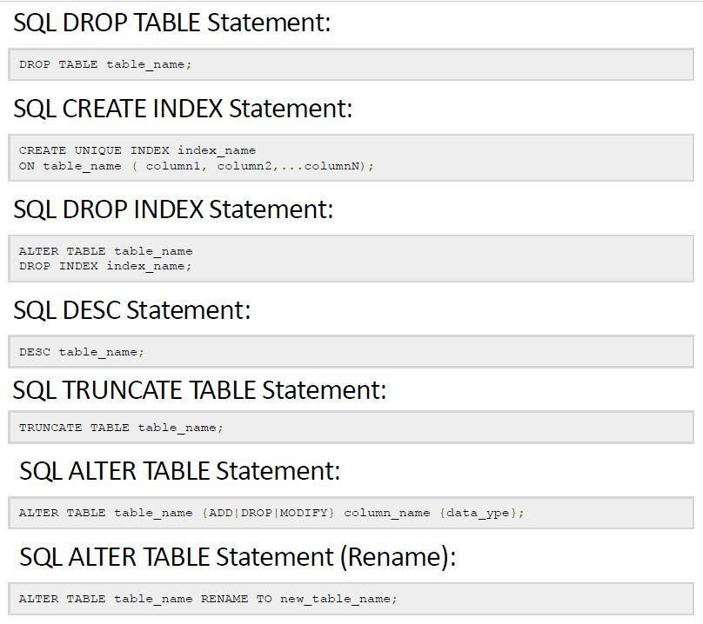

**4. INSERT VALUE (SAMPLE DATA)**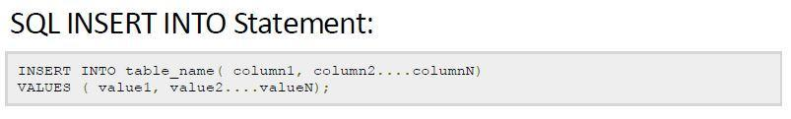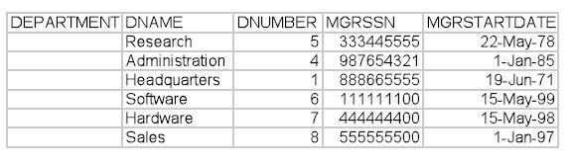

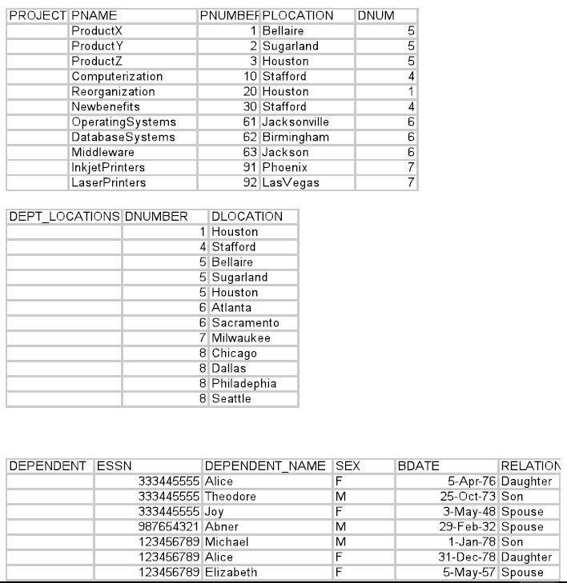

1. **Write the SQL queries for following questions:**
2. Retrieve the birthdate and address of the employee(s) whose name is ‘John B. Smith’.
3. Retrieve the name and address of all employees who work for the ‘Research’ department.
4. For every project located in ‘Stafford’, list the project number, the controlling department number, and the department manager’s last name, address, and birthdate.
5. Retrieve all employees whose address is in Houston, Texas.
6. Show the resulting salaries if every employee working on the ‘ProductX’ project is given a 10 percent raise.
7. Retrieve all employees in department 5 whose salary is between $30,000 and $40,000.
8. Retrieve a list of employees and the projects they are working on, ordered by department and, within each department, ordered alphabetically by last name, first name.
9. Retrieve the names of all employees who do not have supervisors.